# Task 1.1.

**Context**

An organization wants to improve the efficiency of garbage collection of Service provider, but the current systems (UWC 1.0) using only database, so they developed UWC 2.0, based on the UWC 1.0 but with more requirements and can handle many real-time data in the moment and for 5 years

**Stakeholders**

Relevant stakeholders are officers, janitors, and collectors, and service provider Y.

**Current need**

*Back officer:*

1. Have an overview of janitors and collectors, their work calendar

2. Have an overview of vehicles and their technical details (weight, capacity, fuel consumptions, etc)

3. Have an overview of all MCPs and information about their capacity. Information should be updated from MCPs every 15 minutes with the availability of at least 95% of their operating time.

4. Assign vehicles to janitors and collectors

5. Assign janitors and collectors to MCPs (task)

6. Create a route for each collector. Assigned route is optimized in term of fuel consumption and travel distance.

7. Be able to send message to collectors and janitors

*Collectors and janitors:*

1. Have an overview of their work calendar

2. Have a detail view of their task on a daily and weekly basic. All important information should be displayed in one view (without scrolling down).

3. Be able to communicate with collectors, other janitors and back officers. The messages should be communicated in a real-time manner with delay less than 1 second.

4. Check in / check out task every day

5. Be notified about the MCPs if they are fully loaded

*Service provider Y*

1. Need to know all information about back officers, janitors, and collectors, such as their calendar, routes.

2. Need to know all information about vehicles, MCPs.

**Current problems:**

*Back officers:*

1) When using UWC 1.0, they cannot communicate with other collectors and janitors. All updates must be immediately updated in the database, otherwise collectors and janitors will not work correctly

2) UWC 1.0 does not allow back officers to create and assign efficiency route (since it only has a database)

*Collectors and janitors:*

1) Hard to update their task if there is a change in working routine

2) They have to check the availability of MCPs and their task actively since there will not have notification when there is a change in their routine

*Service provider Y*

1) Can yet to obtain information about back officers, janitors, and collectors.

2. Can yet to obtain information about vehicles, MCPs.

**Benefit of UWC 2.0:**

*For back officer:*

1. With UWC 2.0, back officer can contact with collectors and janitors via message, therefore back officers can know their working’s status and can help them if they have problems while working

2. When using UWC 2.0, back officer now have an overview of collectors and janitors’ working calendar, techincal details, MCPs’ capacity, which they will be active in sending appropriate vehicle, active collectors and janitors and managing the central system. They can also make an efficiency route base on the fuel consumption and travel distance.

*For collectors and janitors*

1. With messaging in UWC 2.0, they can update their working status if there is a change in the original work, vehicle, and route. They can also contact with other collectors, janitors and back officers so that they will be ready if other people need them

2. They can check their daily tasks/weekly tasks easily so that they can know what to do next, know whether the MCPs are fully loaded or not.

*For service provider Y*

1. Can track all information about the system.

# Task 1.2

**a) Functional requirements:**

- Back officers can search data for the collectors and janitors, information and capacity of MCPs, technical details

- Service Provider Manager Y can have information about their back officers, collectors and janitors

- Back officers can create and assign an efficiency route base on the vehicle’s fuel consumption and travel distance

- Allow to communicate between back officers, collectors and janitors in real-time (via message, mails, etc)

- Collectors and janitors can view their working routine, daily/weekly tasks and the availability of MCPs

**b) Non – functional requirements:**

- The system must run everyday for every back officers, collectors and janitors working on that day

- Back officers can have an overview of all MCPs and information about their capacity. Information should be updated from MCPs every 15 minutes with the availability of at least 95% of their operating time.

- The messages between back officers, collectors and janitors should be communicated in a real-time manner with delay less than 1 second.

- Collectors and janitors can view their task on a daily and weekly basic. All important information should be displayed in one view (without scrolling down).

- Collectors and janitors notified when MCPs are fully loaded with delay less than 1 hour.

- UWC 2.0 should have at least 2 languages (main language: Vietnamese, can switch to English and other language in the future)

**c) Use-case diagram:**

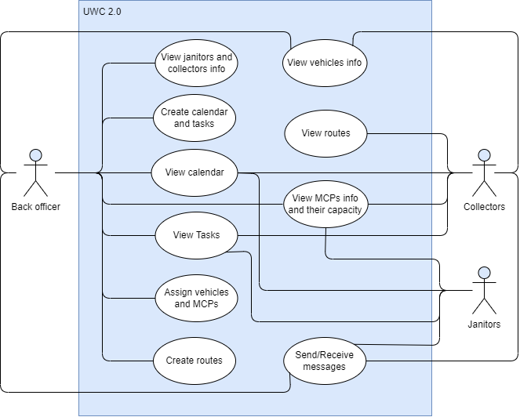

# Task 1.3

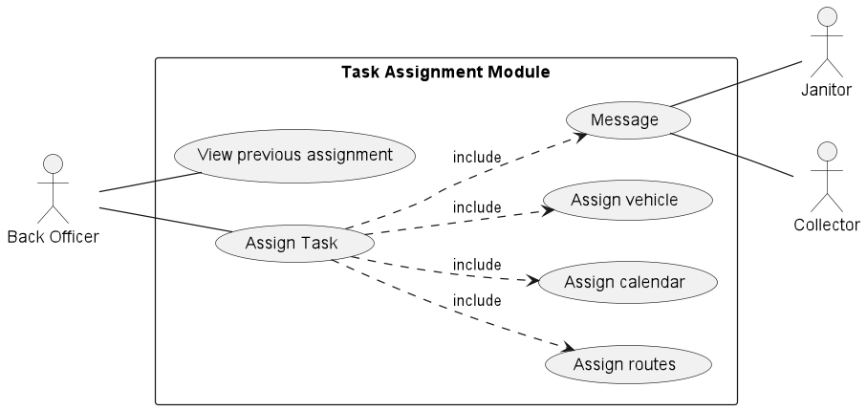

**Table format:**

|  |  |
| --- | --- |
| **Use case name** | Assign task |
| **Description** | Back officers assign tasks to janitors and collectors |
| **Actor(s)** | Back officers |
| **Precondition** | + User is authenticated as back officer  + User is granted access to janitors' and collectors' route calendar database, also vehicle database (to assign right vehicles for the right routes). |
| **Normal flow** | + View old routes and calendars of janitors and collectors.  + Create new routes for janitors and collectors, if neccesary.  + Assign janitors and collectors new calendars (daily task schedule), if neccesary.  + Assign new vehicle for janitors and collectors, if neccesary.  + Message janitors and collectors their new daily work overview and new vehicle assigment. |

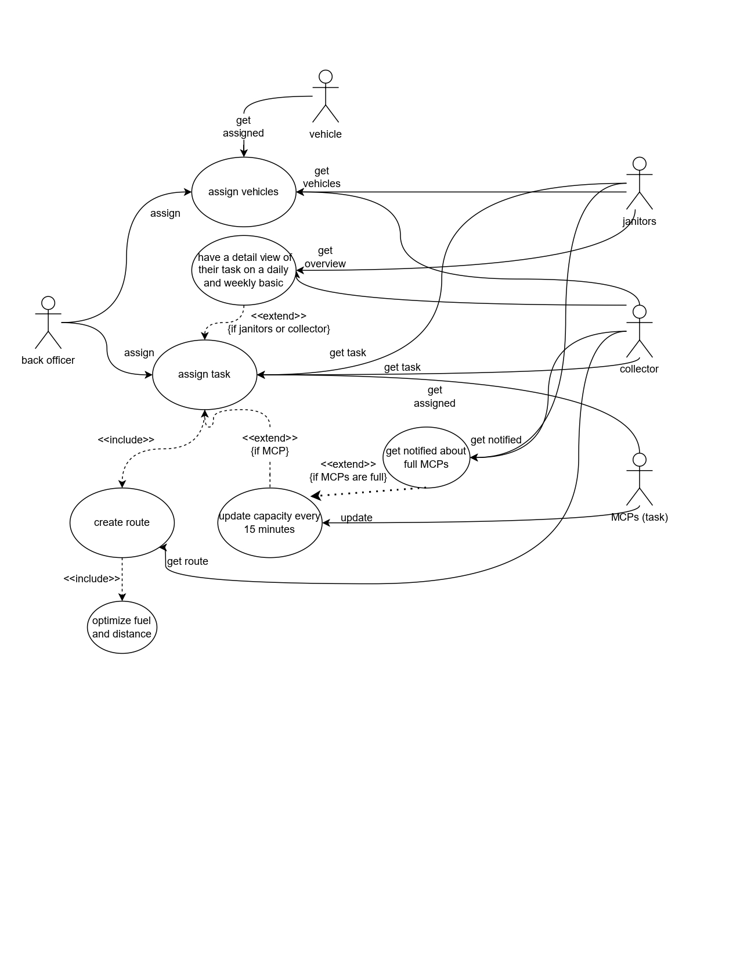

# End of Task 1.